ASSIGNMENT (View)

**NAME : SHISHU REG:2020CA089**

1. A database is being constructed for storing sales information system which store the information of Client. The client have it own unique client number, client name, client addresses, city, address, pin code, state and total balance to be required to paid.

Consider the following schema:

Client (Client_ID, Client_Name, Address, City, Pin, State, Bal_Due)



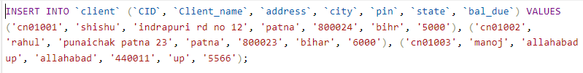

Execute the following queries:

* 1. Create a View called Client_View1 having all data of Client table.



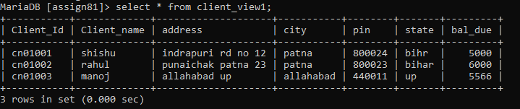

* 1. Create a view called Client_vw2 having Client_ID , city and Bal_Due attributes of client table.

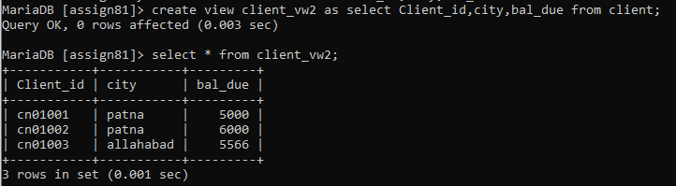

* 1. Create a view called Client_vw3 with renaming Client_ID as CID , Client_Name as cname and Address as Addr of client table.

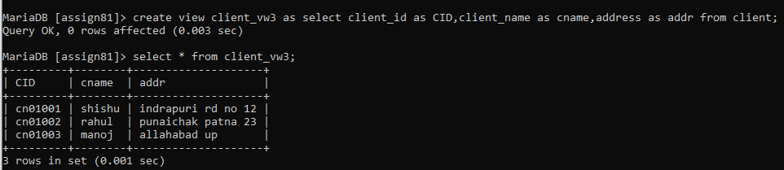

* 1. Using Client_view1, print client_name and Balance of Client whose ID is ‘cn01001’.

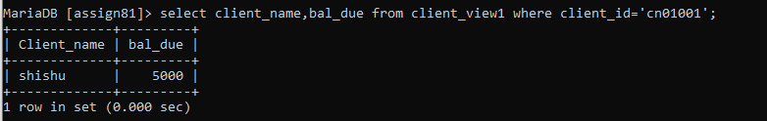

* 1. Insert a row into Client_vw2 (‘cn02003’, ‘alld’, 5000).



* 1. Modify view Client_vw2 such that bal_due of Client_ID CN01004 now become 1000.

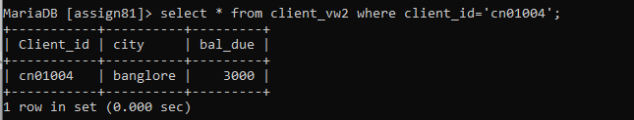

* 1. Delete row from view client_vw2 where Client_ID=’CN02003’.



* 1. Delete view client_vw3 from memory.



* 1. Consider another table Client2 (ClientID, Phone). Create a view client_vw4 which has clientID, Client_name, bal_due and phone. Use both The tables Client and Client2.





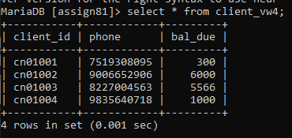

1. A database is being constructed for storing **sales information system**. The customer who buy the item or order the item have it own unique customer id, customer name, customer city, grade and salesman id of those salesman from which they buy the item. Each customer order is to buy item from the salesman. In the order, it has unique sales order number, sales order date, customer id, salesman id and purchase amount to be paid. The elistsalesman have salesman id, name, city and commission which shows the personal details of all salesman.

Consider the following schema:

CUSTOMER (c_id, c_name, city, grade, s_id) SALESMAN (s_id, name, city, commission) ORDERS (o_no, purchase_amt, o_date, c_id, s_id) ELITSALESMAN (s_id, name, city, commission) CUSTOMER

CREATE TABLE CUSTOMER(C_ID INT(5) PRIMARY KEY, C_NAME VARCHAR(30), CITY VARCHAR(15),

GRADE INT(3), S_ID INT(5));

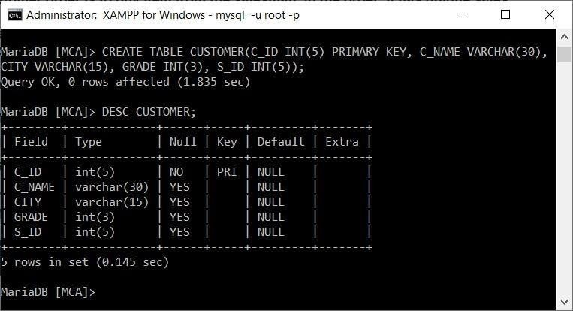

INSERT INTO CUSTOMER VALUES

(3001, 'Brad Guzan'

|  |  |
| --- | --- |
| (3002, | 'Nick Rimando', 'New York', 100, 5001), |
| (3007, | 'Brad Davis', 'New York', 200, 5001), |
| (3005, | 'Graham Zusi', 'California', 200, 5002), |
| (3008, | 'Julian Green', 'London', 300, 5002), |
| (3004, | 'Fabian Johnson', 'Paris', 300, 5006), |
| (3009, | 'Geoff Cameron', 'Berlin', 100, 5003), |
| (3003, | 'Jozy Altidor', 'Moscow', 200, 5007), |

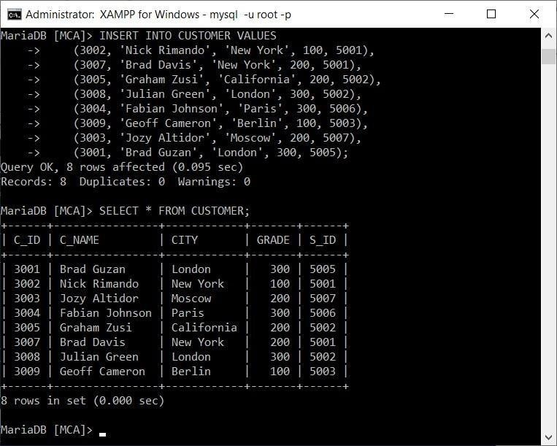

SALESMAN

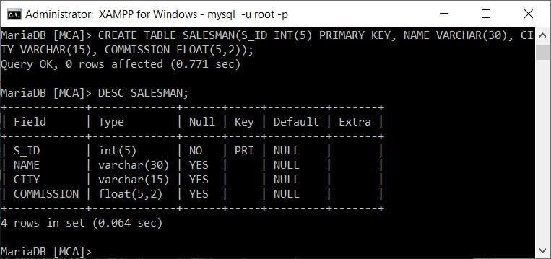

CREATE TABLE SALESMAN(S_ID INT(5) PRIMARY KEY, NAME VARCHAR(30), CITY VARCHAR(15),

COMMISSION FLOAT(5,2));

|  |  |  |  |
| --- | --- | --- | --- |
| INSERT INTO SALESMAN VALUES  (5001, 'James Hoog', | | 'New York', | 0.15), |
| (5002, | 'Nail Knite', | 'Paris ', | 0.13), |
| (5005, | 'Pit Alex ', | 'London ', | 0.11), |
| (5006, | 'Mc Lyon ', | 'Paris ', | 0.14), |
| (5007, | 'Paul Adam ', | 'Rome ', | 0.13), |
| (5003, | 'Lauson Hen', | 'San Jose', | 0.12); |

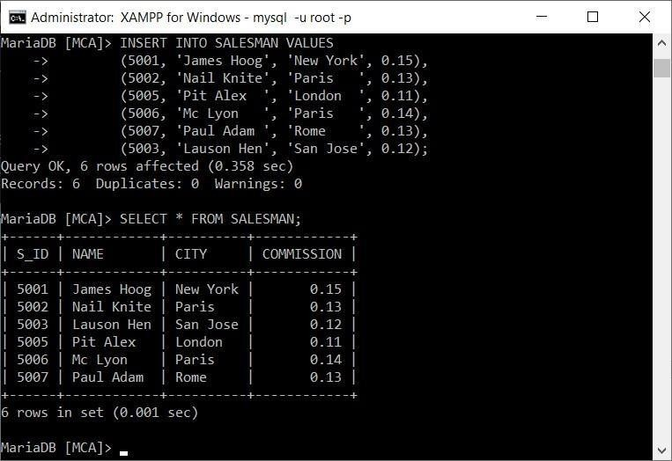

ORDERS

CREATE TABLE ORDERS(O_NO INT(5) PRIMARY KEY, PURCHASE_AMT FLOAT(8,2), OR DATE, C_ID

INT(5), S_ID INT(5));

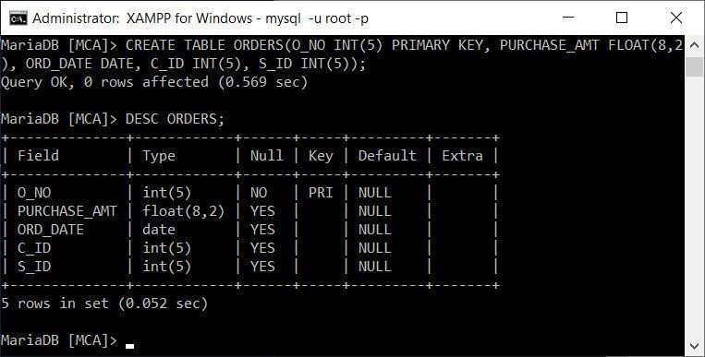

|  |  |  |  |  |  |
| --- | --- | --- | --- | --- | --- |
| INSERT INTO OR  (70001, | DERS VAL  150.5 , | UES | '2012-10-05', | 3005, | 5002), |
| (70009, | 270.65, |  | '2012-09-10', | 3001, | 5005), |
| (70002, | 65.26 | , | '2012-10-05', | 3002, | 5001), |
| (70004, | 110.5 | , | '2012-08-17', | 3009, | 5003), |
| (70007, | 948.5 | , | '2012-09-10', | 3005, | 5002), |
| (70005, | 2400.6, |  | '2012-07-27', | 3007, | 5001), |
| (70008, | 5760 , | | '2012-09-10', | 3002, | 5001), |
| (70010, | 1983.4, |  | '2012-10-10', | 3004, | 5006), |
| (70003, | 2480.4, |  | '2012-10-10', | 3009, | 5003), |
| (70012, | 250.45, |  | '2012-06-27', | 3008, | 5002), |
| (70011, | 75.29 , |  | '2012-08-17', | 3003, | 5007), |
| (70013, | 3045.6, |  | '2012-04-25', | 3002, | 5001); |

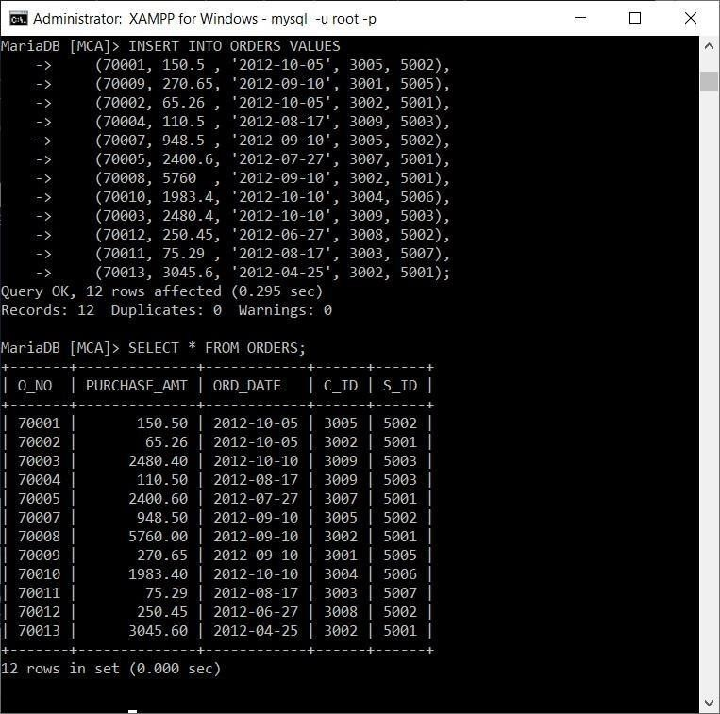

ELITSALESMAN

CREATE TABLE ELITSALESMAN(S_ID INT(5) PRIMARY KEY, NAME VARCHAR(30), CIT VARCHAR(15),

COMMISSION FLOAT(5,2));

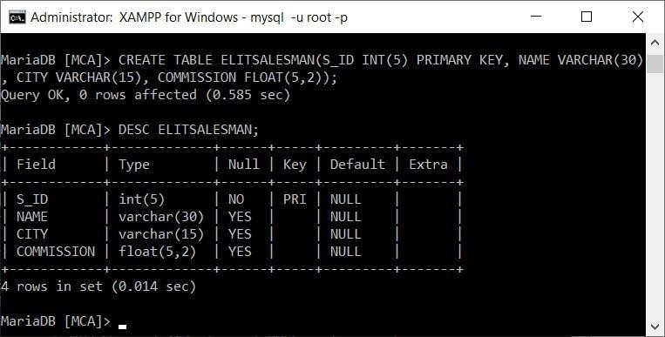

|  |  |  |  |
| --- | --- | --- | --- |
| INSERT INTO ELITSALESMAN VALUES  (5001, 'James Hoog', 'New York', | | | 0.15), |
| (5002, | 'Nail Knite', | 'Paris ', | 0.13), |
| (5005, | 'Pit Alex ', | 'London ', | 0.11), |
| (5006, | 'Mc Lyon ', | 'Paris ', | 0.14), |
| (5007, | 'Paul Adam ', | 'Rome ', | 0.13), |
| (5003, | 'Lauson Hen', | 'San Jose', | 0.12); |

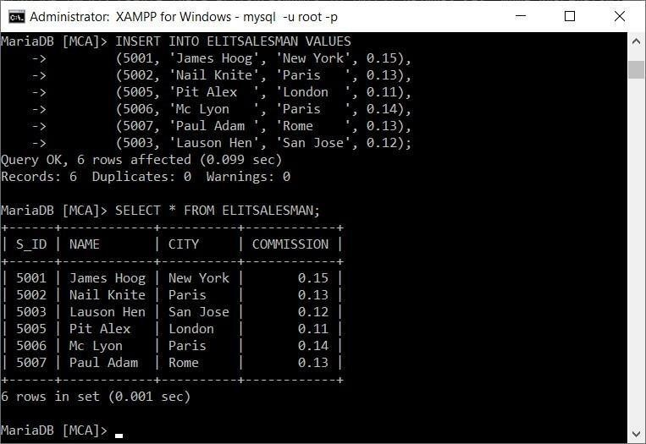

1. **Create a view for those salesmen who belong to the city ‘New York’.**

CREATE VIEW NewYorkStaff AS SELECT * FROM salesman WHERE city = 'New York

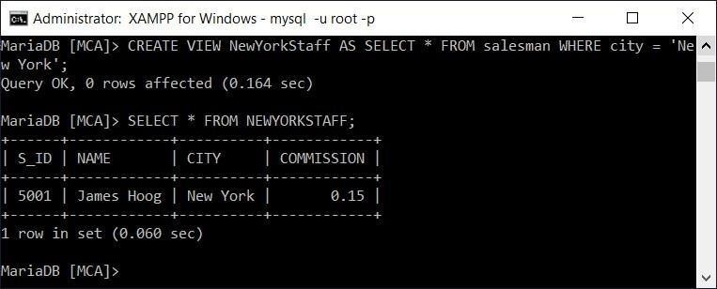

1. **Create a view for all salesmen with columns salesman_id, name and city.**

CREATE VIEW salesown AS SELECT s_id, name, city FROM salesman;

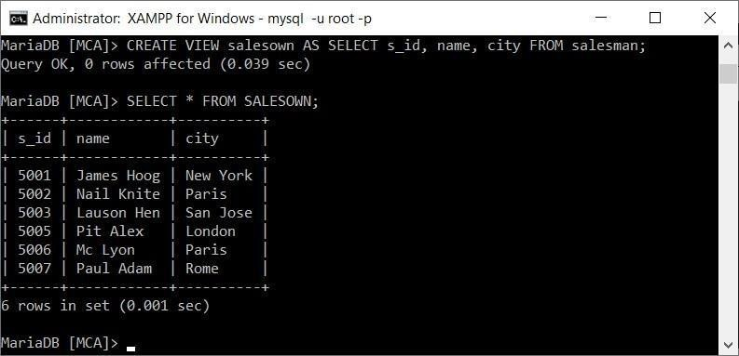

1. **Find the salesmen of the city New York who achieved the commission more than 13%.**

SELECT * FROM SALESMAN WHERE CITY='NEW YORK' AND COMMISSION > 0.13;

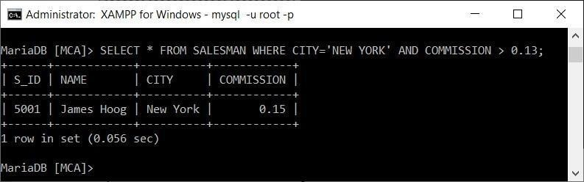

1. **Create a view to getting a count of how many customers we have at each level of a grade.**

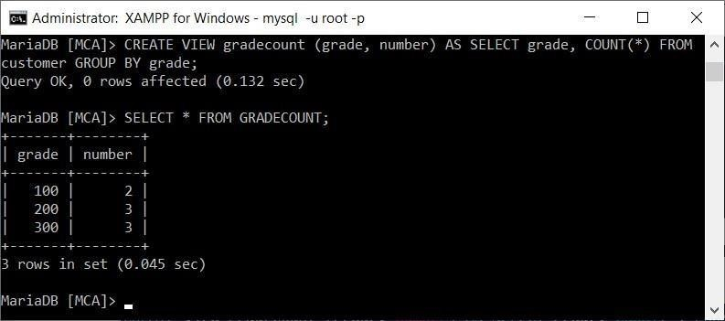

CREATE VIEW gradecount (grade, number) AS SELECT grade, COUNT(*) FROM cu GROUP BY

grade;

1. **Create a view to keeping track the number of customers ordering, number of salesmen attached, average amount of orders and the total amount of orders in a day.**

CREATE VIEW SumPerDay AS SELECT ord_date, COUNT(DISTINCT c_id), AVG(purchase_amt),

SUM(purchase_amt) FROM orders GROUP BY ord_date;

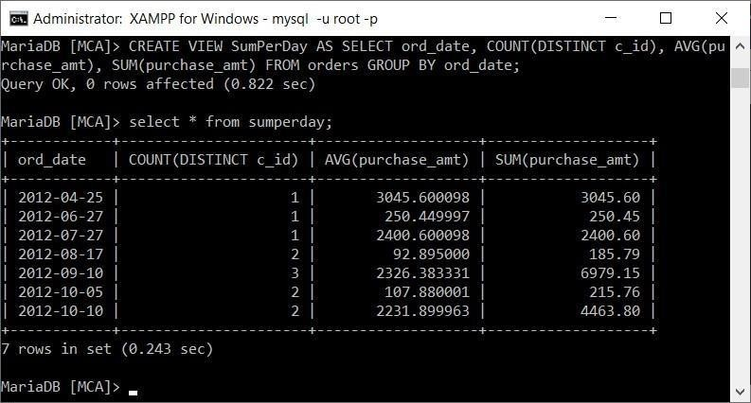

1. **Create a view that shows for each order the salesman and customer by name.**

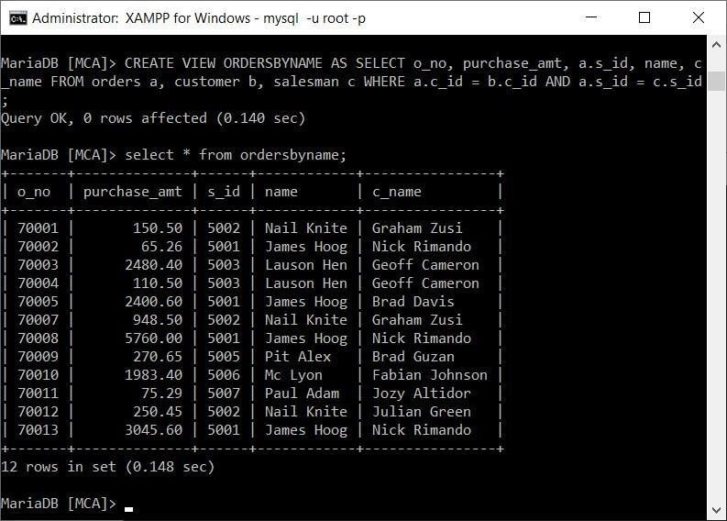

CREATE VIEW ORDERSBYNAME AS SELECT o_no, purchase_amt, a.s_id, name, c_n FROM orders a, customer b, salesman c WHERE a.c_id = b.c_id AND a.s_id = c.s_id;

1. **Create a view that finds the salesman who has the customer with the highest order of a day.**

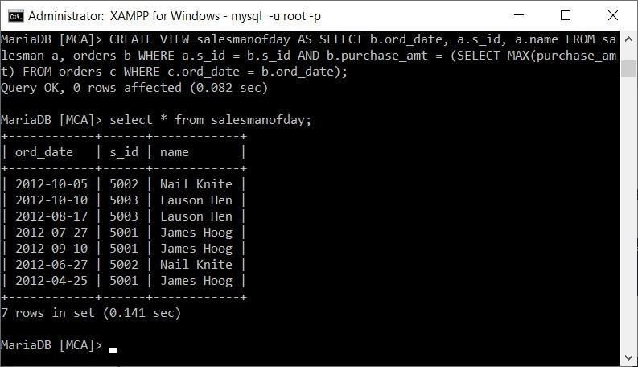

CREATE VIEW salesmanofday AS SELECT b.ord_date, a.s_id, a.name FROM sale a, orders b WHERE a.s_id = b.s_id AND b.purchase_amt = (SELECT MAX(purchase_amt) FROM orders c

WHERE c.ord_date = b.ord_date);

1. **Create a view that finds the salesman who has the customer with the highest order at least 3 times on a day.**

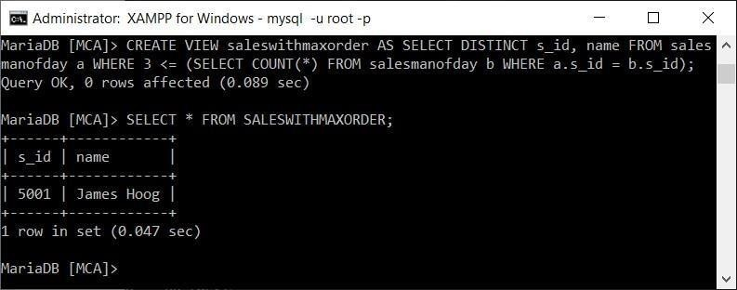

CREATE VIEW saleswithmaxorder AS SELECT DISTINCT s_id, name FROM salesma

(SELECT COUNT(*) FROM salesmanofday b WHERE a.s_id = b.s_id

a WHERE 3 <=

1. **Create a view that shows all of the customers who have the highest grade.**

CREATE VIEW highgrade AS SELECT * FROM customer WHERE grade=(SELECT MAX(

FROM customer);

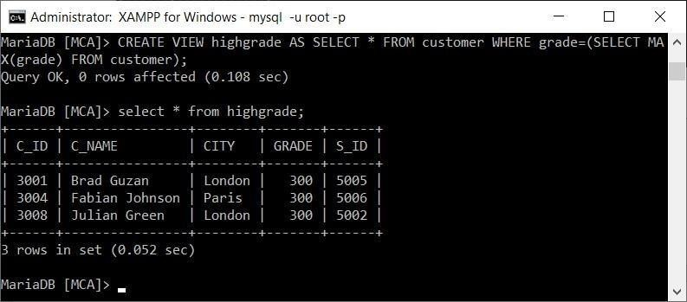

1. **Create a view that shows the number of the salesman in each city.**

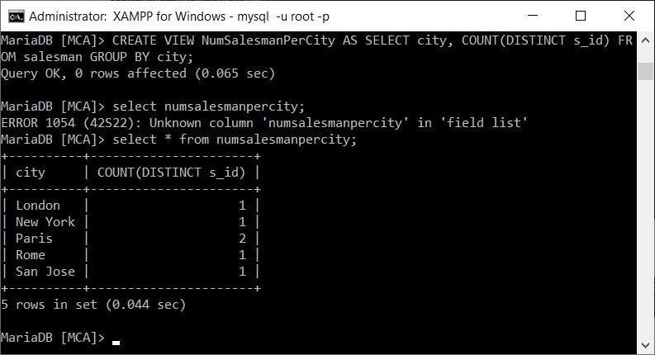

CREATE VIEW NumSalesmanPerCity AS SELECT city, COUNT(DISTINCT s_id) FROM salesman GROUP

BY city;

1. **Create a view that shows the average and total orders for each salesman after his or her name. (Assume all names are unique)**

FROM

CREATE VIEW norders AS SELECT name, AVG(purchase_amt), SUM(purchase_amt) salesman,

orders WHERE salesman.s_id = orders.s_id GROUP BY name;

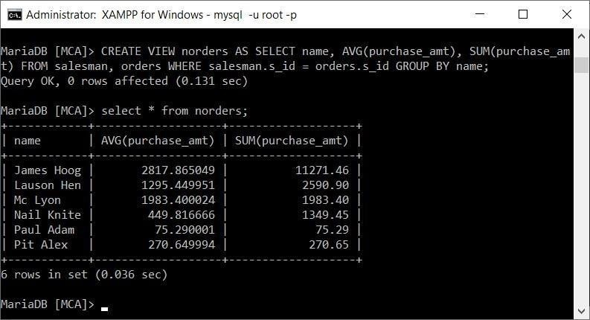

1. **Create a view that shows each salesman with more than one customers.**

*

CREATE VIEW morecust AS SELECT * FROM salesman a WHERE 1 < (SELECT COUNT FROM customer

b WHERE a.s_id = b.s_id);

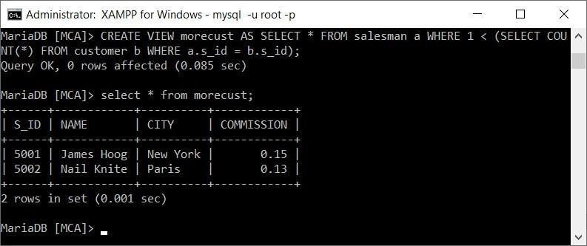

1. **Create a view that shows all matches of customers with salesman such that at least one customer in the city of customer served by a salesman in the city of the salesman.**

CREATE VIEW citymatch(custcity, salescity) AS SELECT DISTINCT a.city, b. FROM customer

a, salesman b WHERE a.s_id = b.s_id;

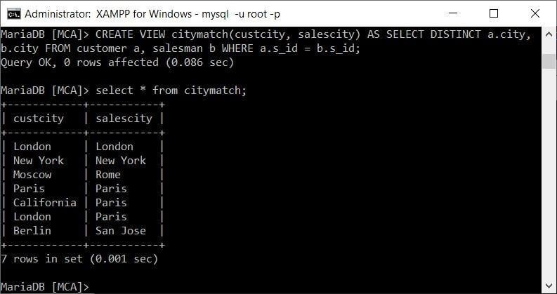

1. **Create a view that shows the number of orders in each day**

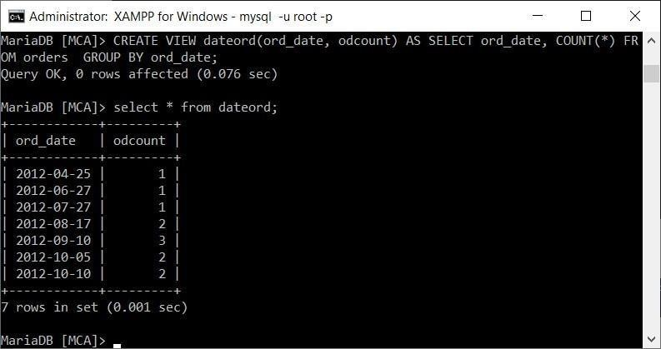

CREATE VIEW dateord(ord_date, odcount) AS SELECT ord_date, COUNT(*) FROM orders GROUP

BY ord_date;

1. **Create a view that finds the salesmen who issued orders on October 10th, 2012.**

CREATE VIEW salesmanonoct AS SELECT * FROM salesman WHERE s_id IN (SELECT FROM orders

WHERE ord_date = '2012-10-10');

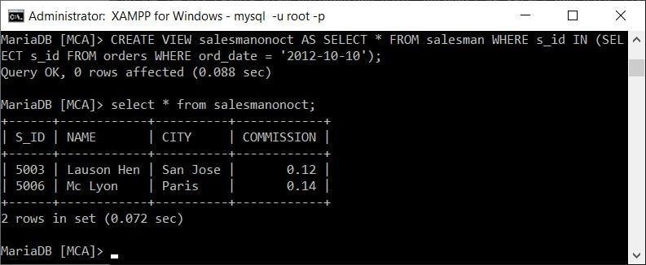

1. 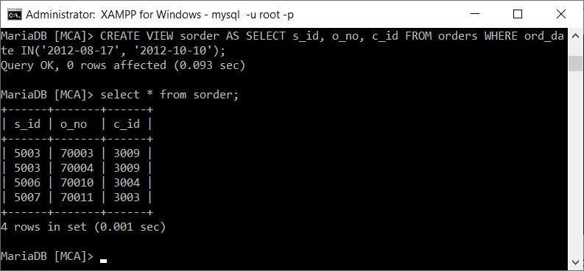**Create a view that finds the salesmen who issued orders on either August 17th, 2012 or October 10th, 2012.**

CREATE VIEW sorder AS SELECT s_id, o_no, c_id FROM orders WHERE ord_date IN('2012-08-

17', '2012-10-10');